|  |  |
| --- | --- |
| Implementation of Business Intelligence and Business Analytics System |  |
| Business Implementation Report | Author:  Seán Healy  Amy Webster & Stefano Piras  Date Issued: 17/08/2021  Version:  1.0 |
| SAS Recruitment   |  |

Table of Contents

1 Document Reference 3

1.1. Document Reference 3

1.1.1. Sign Off 3

1.1.2. Document History 3

1.1.3. Distribution List 3

2 Introduction 4

2.1. Audience 4

3 Business Strategies 5

3.1. Balanced Score Card 5

3.1.1. BSC Figure 5

3.2. SWOT Analysis 7

3.3. Kotter’s Strategy for organizational changes 9

3.1. Competitors Analysis: 10

4 Development Process 14

4.1 Solution 14

4.1.1. Company Data 14

4.1.2. Data Collection 14

4.1.3. Mockaroo 15

4.1.4. Kaggle / Excel 15

4.1.5. Information Lifecycle Management (ILM) 15

4.1.6. Marketing Funnel 15

5 Implementation Process 18

5.1 Solution 18

5.1.1 Software 18

5.1.2 Dashboards 18

5.1.3 Strategic Dashboard 19

6 Benefits 21

6.1 Company Benefits 21

6.2 Employee Benefits 22

7 Future Work 24

8 Teamwork 25

6.1. Glossary 25

9 Bibliography 26

10 Appendix 27

# 1 Document Reference

## Document Reference

### Sign Off

|  |  |  |
| --- | --- | --- |
| Signatory | Role | Sign Off Date |
| Sean Healy | Lead Business Analyst | Received via email 16/07/2021 |
| Amy Webster | Lead Business Intelligence | Received via email 16/07/2021 |
| Stefano Pires | Lead Data Analyst | Received via email 16/07/2021 |

### Document History

|  |  |  |  |
| --- | --- | --- | --- |
| Vers | Author | Issue Date | Description |
| 0.1 | Amy Webster | 28/07/2021 | Initial draft for review |
| 0.2 | Stefano Piras | 29/07/2021 | Updates |
| 0.3 | Sean Healy | 06/08/2021 | Updates |
| 0.4 | Stefano Piras | 08/08/2021 | Update |
| 0.5 | Amy Webster | 10/08/2021 | Updates |
| 0.6 | Amy Webster | 11/08/2021 | Updates |
| 0.7 | Stefano Piras | 11/08/2021 | Updates |
| 0.8 | Sean Healy | 11/08/2021 | Updates |

### Distribution List

| Recipient | Role | Company |
| --- | --- | --- |
| Sean Healy | Business Analyst | SAS Recruitment |
|  | Business Analyst |  |
|  | Operational Project Lead |  |
|  | Head of Business Architecture |  |
|  | Functional Architect |  |
|  | Functional Architect |  |
|  | QA Specialist |  |
|  | Development Manager |  |

# Introduction

The purpose of this document is to outline the implementation, building from the initial requirements document of the Enterprise System including Client Relationship Management tool with business intelligence and data analytics capabilities.

This document provides a detailed report describing the development process, final architecture, process control features along with the operations and benefits of the solution. Detailed visuals will show the system in action and how the data management is fulfilled. Dashboards and reports supplied directly from the system will also be shown in this document. The benefits to the company and employees will be outlined.

A final section on the project teamwork will be included towards the end, discussing how we as a team worked together to come to this solution for the company at hand.

## Audience

This document is written for review and signoff by those individuals who have been nominated as subject matter experts/sign off authorities for Business Intelligence and Business Analytics as a complete list of business requirements for the in-scope subject matter.

# Business Strategies

## Balanced Score Card

The balanced scorecard is a well-known “strategy management framework” designed to “allow companies to pool information in a single report” [1].

It is one of the most popular approaches well known among managers for its versatility and adaptability. One of its major benefits is that it “minimizes the information overload by limiting the number of measures used. […] The balanced scorecard forces managers to focus on the handful of measures that are most critical” [2].

It allows to look at the business from 4 different perspectives:

* Financial
* Customer
* Internal Process
* Learning and Growth

It defines the objectives the management need to focus on, the measures adopted to control the improvements, the initiatives taken to reach the objectives and the actions needed that arises after every meeting.

The following is the BSC designed for the SAS Recruitment. It mainly focuses on the digitalization of the company by adopting the Microsoft Dynamics CRM, on the performance increase by improving the selection, training and mentorship of the candidates, and the increase of the brand awareness by lunching dedicated marketing campaigns.

### BSC Figure

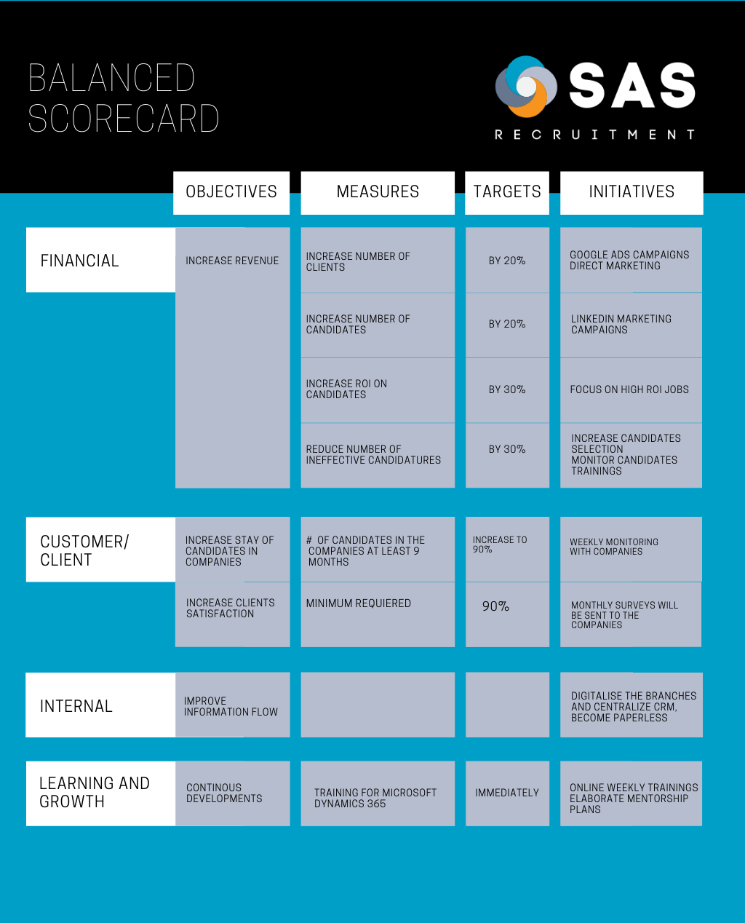

## SWOT Analysis

The SWOT analysis is a framework popular among managers for its ability to position the company in the business scenario comparing it with its competitors.

It is “used to evaluate a company's competitive position and to develop strategic planning. SWOT analysis assesses internal and external factors, as well as current and future potential” [1]. It is composed by the internal factors of a company, Strengths and Weaknesses, and the external factors, Opportunities and Threats.

The big change the SAS Recruitment is planning to implement, i.e. the migration of the databases located in the various locations to one on the Microsoft Dynamics, has the intention to tackle the weaknesses that the company is currently facing, especially with competitors constantly upgrading their technology at the state of the art.

The following is the SWOT analysis of the SAS Recruitment:

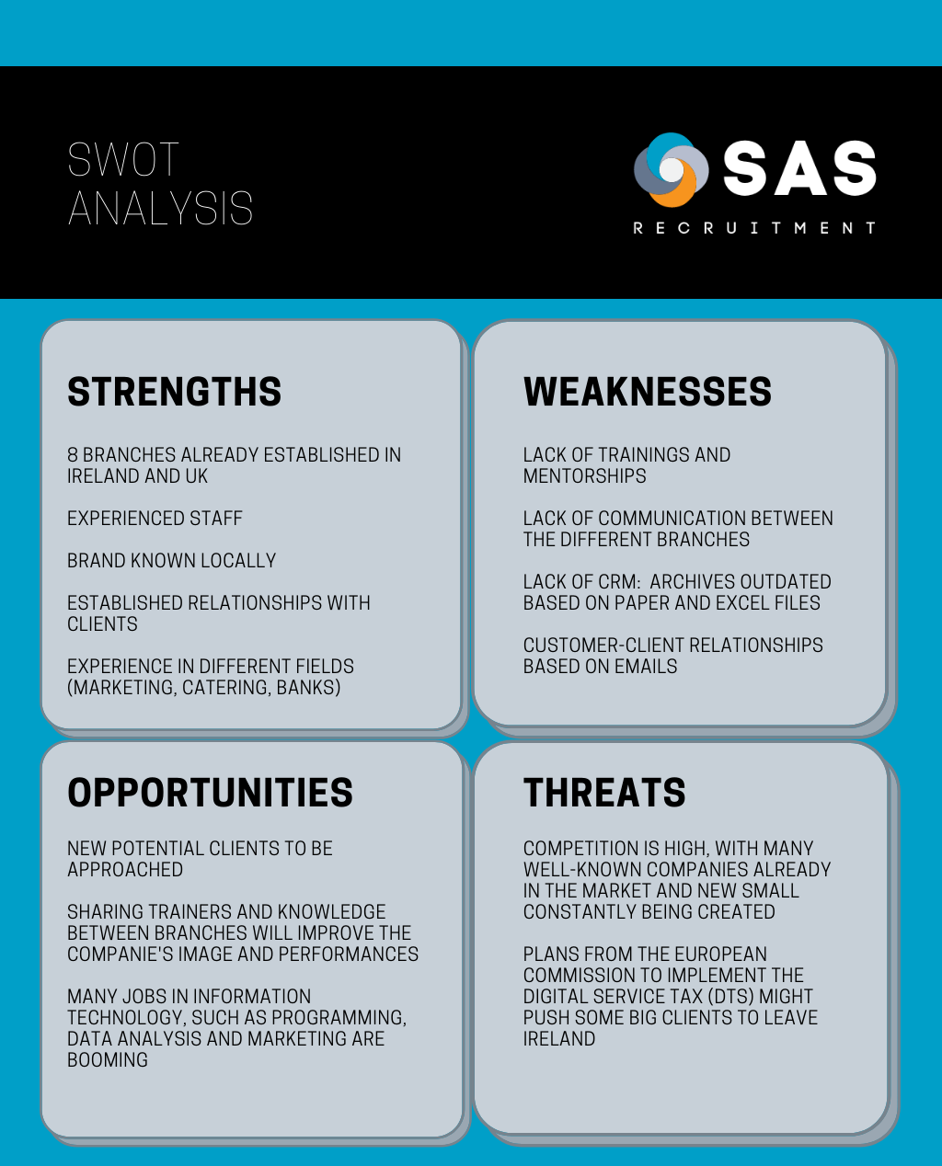

#### Competitors Analysis:

The following is the list of the most known recruitment agencies in Ireland. The list is not ordered by importance, by revenue, by market share nor by number of employees, because the numbers are generally not disclosed by the companies. As mentioned before, it is important to underline the increasing trend of small agencies that appear in the recruiting scenario often to take advantage of new market segments, new investments or, more in general, new opportunities.

Cotter Personnel Ltd

CPL

Action Recruitment

Adecco Ireland

Abrivia Recruitment Specialists

Approach People Recruitment

Ascension Executive Recruitment

Bracken Recruitment

Beautiful Jobs

Top Chefs Career & Recruitment

Brightwater Recruitment Specialists

Broadline Recruiters

CareerWise Recruitment

Hays Ireland

Executive Talent

Executive Edge

Excel Recruitment

Fusion Recruitment

ITL Recruitment

EXEC Search & Recruitment

Irish Recruitment (IRC)

Such list can be easily found on the well-known job website www.jobs.ie or on the www.goldenpages.ie.

The jobs they work on are generally categorised in the following groups:

Accountancy

Asset & Investment Management

Banking & Fund Services

Call centre jobs

Construction

Customer Support

Executive Search

Finance

Fintech

Healthcare

Human Resources

Information Technology

Insurance & Actuarial

Legal

Manufacturing

Marketing

Pharmaceutical

Retail

Sales & marketing

Social Care

Supply Chain

Taxation

To identify new opportunities that might arise in a fast-changing market such the Recruiting and to prepare the company and the employees timely, it will be vital for the SAS Recruitment to be constantly updated on the competitor’s scenario and to also keep monitored the job categories that are in high demand.

Any change in the competitor’s scenario, i.e., a competitor expanding its area of expertise or reducing its resources on others as also new job categories increasing in demand when big companies show on the market (see the recent example of Tik Tok) might result to be a treat if unnoticed or an opportunity if noticed on time and if the SAS Recruitment is able to change and adapt its structure to action rapidly.

## Kotter’s Strategy for organizational changes

The Kotter’s methodology has been developed to help organizations in areas demanding change such as efficiencies, innovation, growth, culture, digital transformation [1].

Particularly for the last point, digital transformation, the Kotter’s strategy is considered helpful for this project because the SAS Recruitment has the plan to become a paperless company and to move all the paper and excel archives into the Microsoft Dynamics 365. This change might find much resistance, in particular from senior employees, who might be reluctant to embrace the digitalization or from departments distributed in the 8 branches, used to work independently, who might be reluctant to share information with the departments from other locations, seen very often as pure competitors.

Kotter’s comes helpful in these situations with its methodology that is summarized in the following 8 steps:

1. [Create a sense of urgency](https://www.kotterinc.com/8-steps-process-for-leading-change/#step-1)
2. [Build a guiding coalition](https://www.kotterinc.com/8-steps-process-for-leading-change/#step-2)
3. [Form a strategic vision and initiatives](https://www.kotterinc.com/8-steps-process-for-leading-change/#step-3)
4. [Enlist a volunteer army](https://www.kotterinc.com/8-steps-process-for-leading-change/#step-4)
5. [Enable action by removing barriers](https://www.kotterinc.com/8-steps-process-for-leading-change/#step-5)
6. [Generate short-term wins](https://www.kotterinc.com/8-steps-process-for-leading-change/#step-6)
7. [Sustain acceleration](https://www.kotterinc.com/8-steps-process-for-leading-change/#step-7)
8. [Institute change](https://www.kotterinc.com/8-steps-process-for-leading-change/#step-8) [2]

The sense of urgency, “developed by very creative means, gets people off the couch, out of a bunker, and ready to move” [3]. To create a sense of urgency, the plan contains a few actions oriented to make employees aware of the necessity to embrace digitalization because all the competitors have, with different CRM, done the same change that brought them a massive competitive advantage.

To address the second point, the management will appoint a “change group” parallel to the management structure. This group will be formed by senior and newbies who show some interest in the digitalization. To avoid common mistakes done in this phase by managers [4], the guiding coalition will be formed by employees who truly show enthusiasm in digitalization and have shown interest in streamlining the procedures. The management will stay engaged with the coalition with weekly meetings.

In order to create a vision that can be appealing for all employees, various sessions will be held to underline the advantages of embracing the digitalization, such as the ability to get the contact of anyone withing the organization and get the information needed withing seconds, or the ability to improve the matching between the candidacies and the job vacancies using the machine learning offered by the platform.

Regarding the fourth point, the ‘army’ will be created on a volunteer basis. The volunteers will belong to all the departments, HR, Trainers, Accountants, Recruiters and so on. “They have the knowledge, experience, and social networking abilities to lead the internal forces within the organization” [5].

Barriers are what blocks people to give their best in every aspect of their life. In this delicate moment of change of the company structure, particular attention will be dedicated to any barrier that might prevent employees to feel encouraged to embrace the change, to participate in it and to contribute to it in their best way. One way to remove barriers is the implementation of a weekly survey offered to all employees to identify any obstruction that is limiting their action and to find solutions to remove them. The surveys will focus particularly on how employees are adapting to the new technology, to check if the trainings have been sufficient or if the employees need more support, even with different approaches, and to check if they are noticing the benefits promised by the change.

‘Wins are the molecules of results. They must be recognized, collected and communicated – early and often – to track progress and energize volunteers to persist’ [2]. On a weekly basis, the short-term wins will be emphasized both on the company newsletter and in the meetings.

Regarding the seventh point, in order to keep the momentum of the change, until the system has been deployed and the different location start working as a single entity (we recon this might take years), the management will need to keep employees posted via email and during the meetings, regarding the single successes and achievements and eventually regarding any possible drawback.

The change needs to be considered normal withing the organization in order to allow further modifications and updates to be accepted without instinctive repulsions. At every chance the progresses of the change will need to be mentioned and success stories will be told and repeated. The change values will need to be included when hiring and training new staff. The members of the original change coalition will be publicly recognized, and those leaders who move ahead with their careers will be replaced with leaders who share the same values to avoid their legacy not to get lost or forgotten. [6]

# Development Process

## 4.1 Solution

### Company Data

The company data comprises of many different tables.

1. Candidate information - Contact information; First Name, Last Name, Email, Phone number, Address. Work history; Industry, Job Title, and Reference Details; Name, Company, Position, Phone:

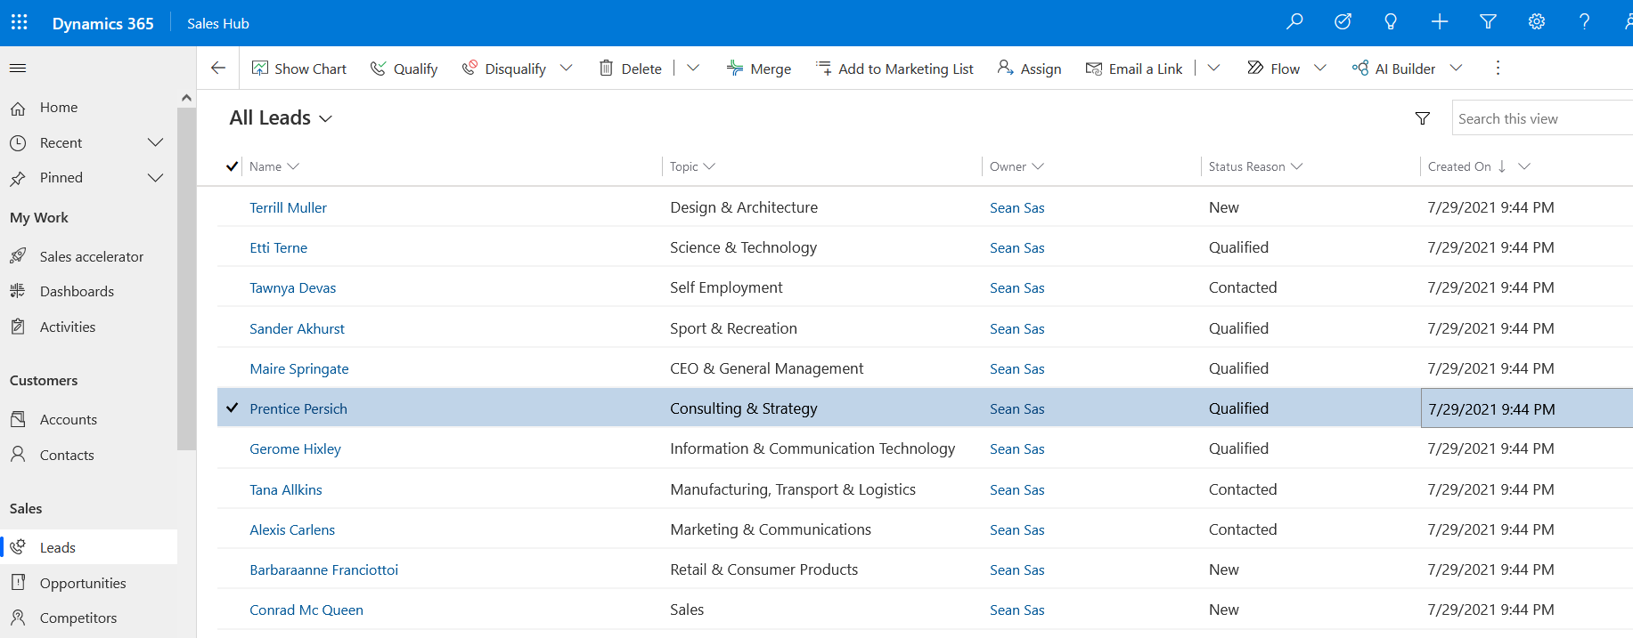

For our implementation: Leads = Candidates

1. Client information (existing) - Contact information; First and Last name, Email, Phone, Company.

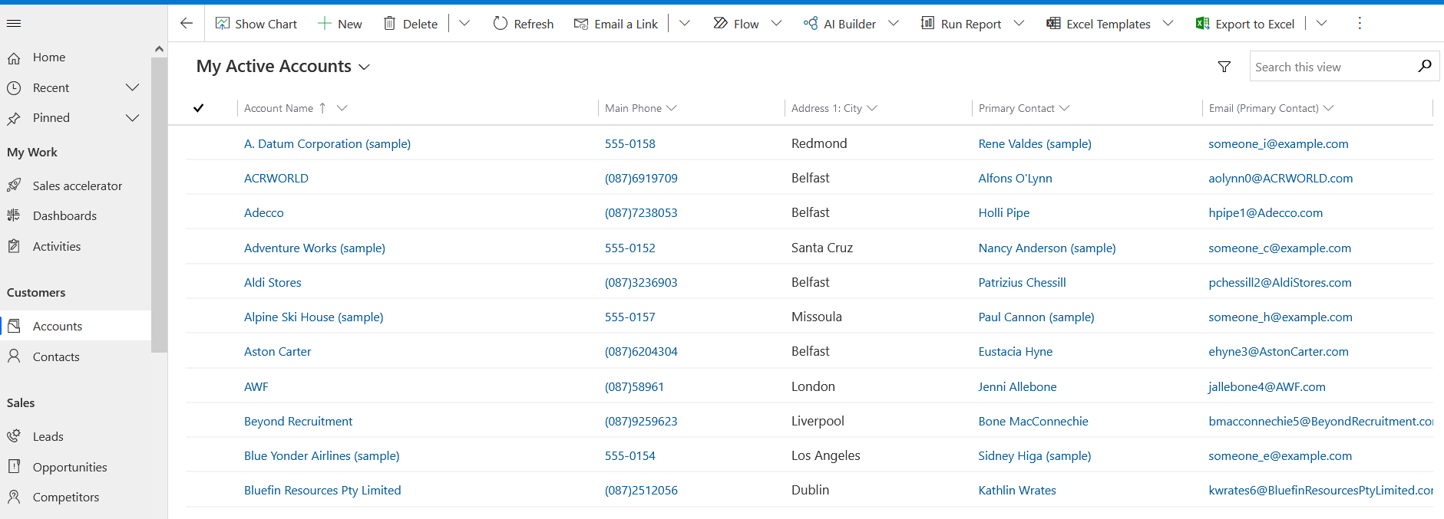

For our implementation: Accounts = Clients.

1. Client contact (existing) - Contact information; First and Last name, Email, Phone, Company, industry requiring staff for, Number of staff requested.

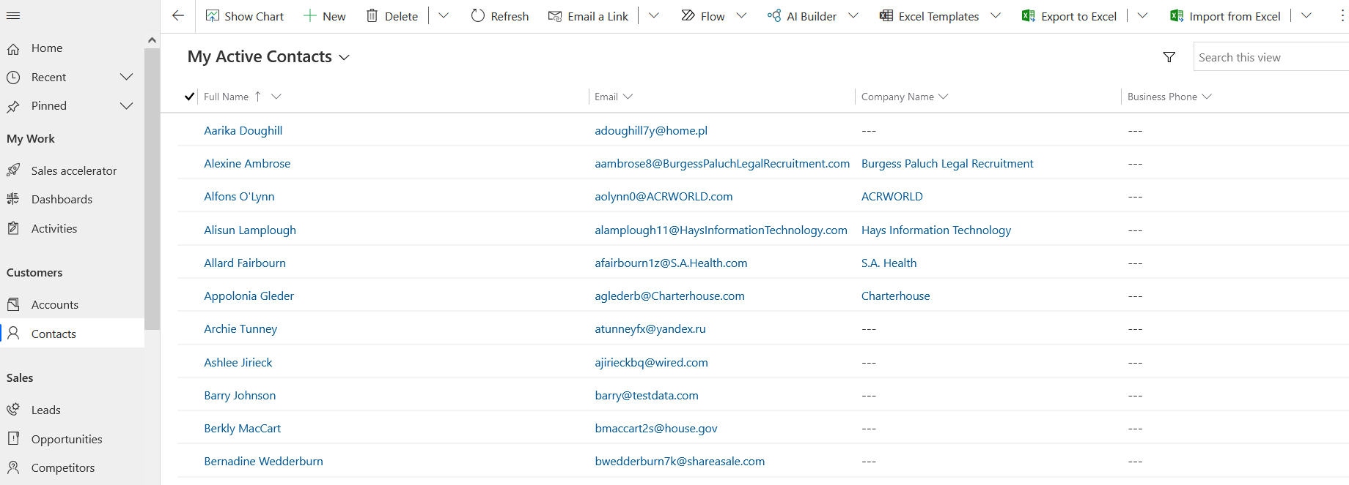

1. Job Listings – Job title, Sector, Description, Requirements, Company.

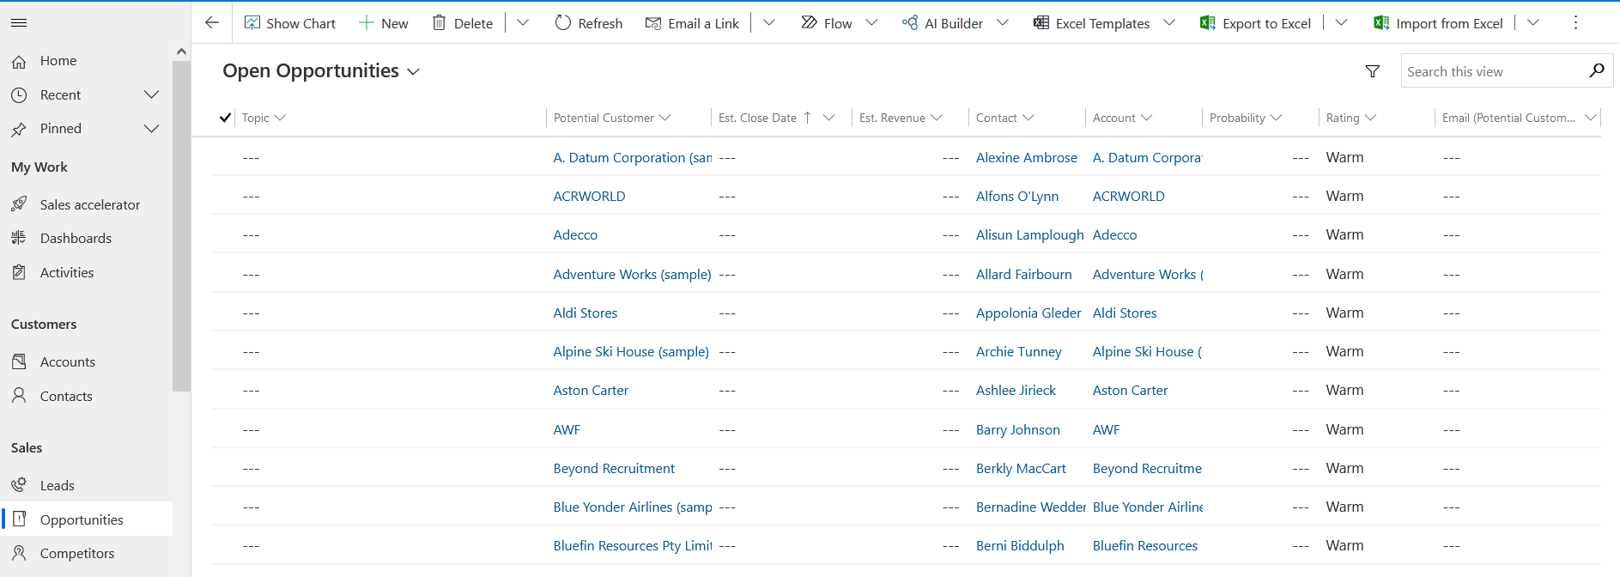

For our implementation: Opportunities = Job Listings

1. 5. Marketing list - Contains Client leads from the website, these are not yet Clients but have the potential to be.

### Data Collection

SAS Recruitment will collect data for Candidates and Clients from their website. The data collection will be via forms on specific pages of the site. For example, Candidate registration page will be on the navigation bar and is for capturing candidate’s info. Similarly, for new Clients to request staff (Client Registration Form) and become our client a form will also be on the website, this is for new clients to request staff for a sector. Current Clients will already be saved in our database.

Contact us form will also allow us to collect some data, mainly queries from website visitors. This information doesn’t need to be saved for long time, unless attached to a current matching profile by using the email address supplied.

Job Applications data is similar to the candidate registration form however we require less data at this stage. The user is applying for a specific job and uploading their CV and Cover letter as a message to match this job description. This will be saved, and a recruiter will screen it and decide on the next steps.

All data from the website forms will be saved into the CRM. Any data from business development i.e., new clients will be sent to the website to also sign up (fill out the Client Registration form) after initial relationships have been made, so that all information is collected and dealt with the same way going forward this will save time and help remove the possibility of human errors from copying data over from emails or handwritten documents.

### Mockaroo

Mockaroo.com is a well-known site that allows the creation of data, this is normally used for generating mock data for testing new systems with example real life data. The data we created is similar to real data that would be used in by the business. As the user is allowed to create data in 1000 rows at a time for free, we have created 7000 rows of ‘Candidate Data’ which will be used for our analysis.

As outlined above in 4.1.1 Company Data we used Mockaroo.com to build out the data we needed. This included Candidate information, Client information existing and new, Job listings, job applications, Employee data.

### Kaggle / Excel

Kaggle.com was used to source the vacancy details to keep the project as realistic as possible. We sourced a dataset with 20’000 rows of data based on the Australian market 2018. Using MS Excel we manipulated the data to mimic Irish data, for example using Irish cities and towns and GEO positions.

### Information Lifecycle Management (ILM)

Ensuring we safely use and store our data in the new system as per the regulatory requirements. Remove any data after time periods or requests as per GDPR. Ensuring data can only be accessed by the right members of the team. E.g., payroll details by accounting only.

The main log in users of Chief Operations Officer (COO) and Business Analyst (BA) and other high-level management will have access to view all data from all offices if needed, this will be good for high level management to view how the company is doing as a whole and for the BA to draw on trends and patterns. The smaller offices should be restricted to viewing their data only and only the level access needed per user role. There is no need to share the entire company details with every location/user, it must be safely stored.

Detection and prevention process will be in place for the cloud ensuring notifications are on for the right person on the IT team when any policy violations or data replication or injection attacks take place. This is called DAM Database Activity Monitoring.

Microsoft Dynamics 365 has strengthened data privacy built in, with recovery and 24-hour technical support.

### Marketing Funnel

The marketing funnel or the customer journey is used a lot for many companies; in our case it is slightly altered to accommodate our specific use case which is recruitment. Every touch point on the internet is valuable nowadays especially for brands. Learning about a brand takes time. You need to trust the brand and its information before you will do business with them. The same goes for recruitment. There are many companies out there battling for the same clients and candidates, businesses need to be unique and trustworthy. Every touch point from social media to ads to answering an email is like a “road sign” directing users to your website. If you have a bad “sign” those users will not make it to your website and will more than likely head to the next recruitment site with better “signs” instead.

A brief overview of how we will use it for this company:

We have two main customer journeys to follow. 1. Candidate journey this is B2C (Business to Consumer) 2. Client journey this is B2B (Business to Business). See the figure below explaining these in more detail.

**Lead generation** is every way in which we find new clients and candidates. Social media pages posting valuable content to grow the social media presence and center the company as the expert in the recruitment field. Landing pages to enable potential candidates fill out forms with their details if they are interested in upcoming sectors that the company have not entered before, this will build our candidate list for that area, while not asking for all the details on a candidate registration form. This makes gathering their details quicker and easier for the user. Running Facebook and LinkedIn ads for particular jobs (where your potential candidates spend time). Business development will help to find new clients going forward. Existing lead generation is the use of Jobs boards like IrishJobs.ie and Indeed.

**Lead Nurturing**, this stage is where we will contact our lists of candidates with valuable information pertaining to their desired sectors and upcoming jobs, they may be interested in. Leading them back to the website in many cases. For clients we keep them updated on the work we have been doing throughout the year and any benefits to them as a client of ours. Also letting them know we are on top of all thing’s recruitment. We share facts and figures from the last month ensuring of this.

The last stage is the **sale**. In this case the sale for our company is the candidate being placed in a job or gaining another client to fill jobs for going forward.

The website will also include tracking with Google Analytics. This will allow the company to keep track of the best pages on the site and any conversions taking place i.e., applications or forms submitted. This data can also show the number of website visitors’ month over month.

Using other software like HotJar to track users on the site will allow us to make decisions on the website’s usability from a User Experience point of view. If any changes need to be made to help the customer journey. The least amount of clicks it takes a user to fulfil the journey the better – make it easy to apply.

The website will also include tracking pixels for social media, this is so the company can retarget website visitors with remarketing ads in the future. If a specific sector page has been visited etc… creating a personalised list of potential candidates going forward.

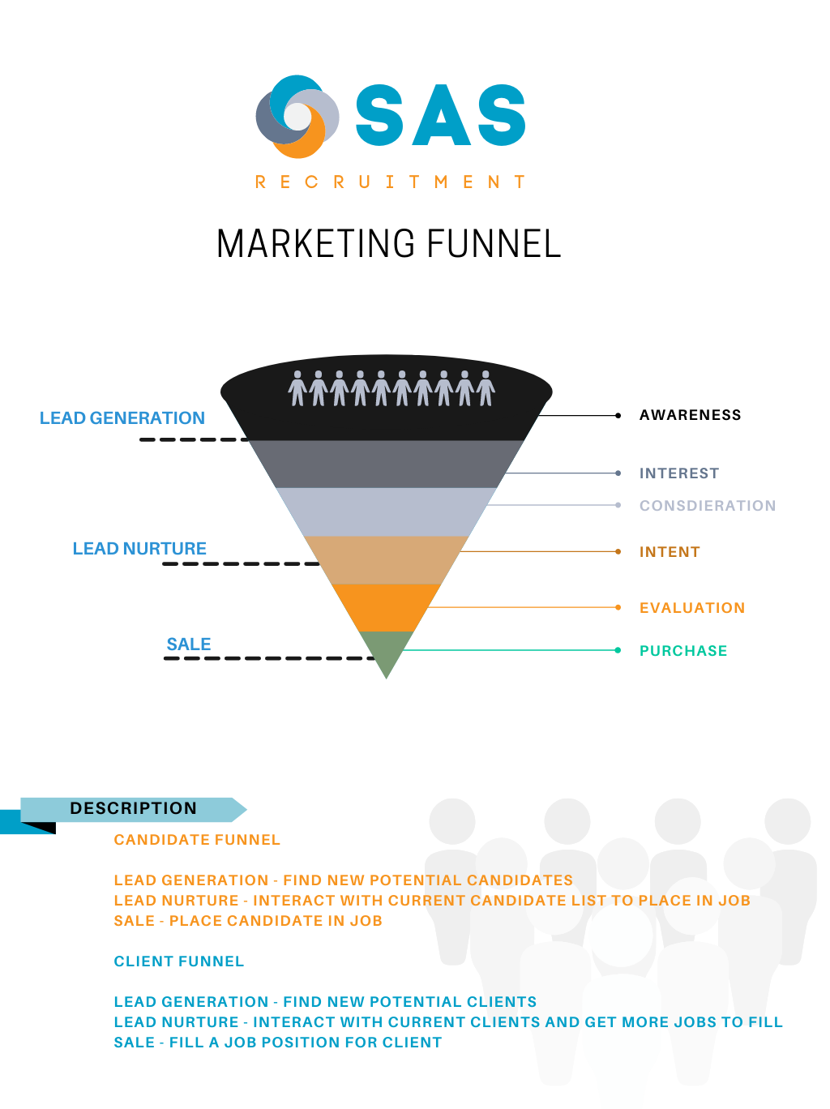

# Implementation Process

## Solution

## 5.1.1 Software

Microsoft Dynamics 365 is the software used in the implementation process; it is both a CRM system (customer relationship management) as well as ERP software (Enterprise Resource Planning). This software has great capabilities due to this and will see the company well into the future not just right now. It has modularity that allows companies to add different functionalities as needed for many departments like sales, marketing, customer relations and operations ensuing the company does not outgrow it but instead it grows while the company grows. It is a SaaS (Software-as-a-service) which means it is cloud based and the user/company SAS Recruitment has access to the software for a set period, the entire infrastructure is managed through the cloud, this has great benefits including ease of use and more cost effective.

Many companies are used to working with Microsoft products as is SAS Recruitment, and this is another reason to take on this software, many employees are already familiar with the look of a Microsoft products. As mentioned already there will be training, and this will help employees afraid of change to learn quicker and rapidly see the results a system like this will return.

Microsoft Dynamics has many uses and for SAS Recruitment we are using the many settings for the following:

|  |  |
| --- | --- |
| Dynamics Label | SAS Recruitment label |
| Leads | Candidates |
| Accounts | Clients |
| Marketing Lists | Company leads from the website not a client yet, try to get them as company client |
| Opportunity | Job Listings |
| Qualify | Screen |
| Develop | Interview |
| Propose | Offer |
| Close | Accept / Reject offer |

## Microsoft Dynamics for Marketing:

The marking module of Microsoft Dynamics allows the creation of marketing forms, these are useful to pipe the data into the system. The forms would be on the company website and users of the website such as potential candidates can enter in their details on the site and the system will save the data. The forms created for this project are the candidate registration from, client registration form and a contact form. The process for building these forms is very simple, on the left-hand side go to Internet Marketing and select Marketing forms. It is a drag and drop user interface for the input fields, you can edit the form labels and select whether you want to make them required or not and also add a submit button. It creates the HTML that you can send to the website developer. You can also set up if you want to display a marketing page after submission, (example page created below in screenshot) for this project the web developer will be creating his own pages so the HTML is all that is used, the website theme will also play a role in the form design and colours. Another option is to send off and confirmation email this is useful and good UX practice so the user knows their details have been received and similarly with the contact form that the query has been received.

The screenshot below is of the registration form user interface.

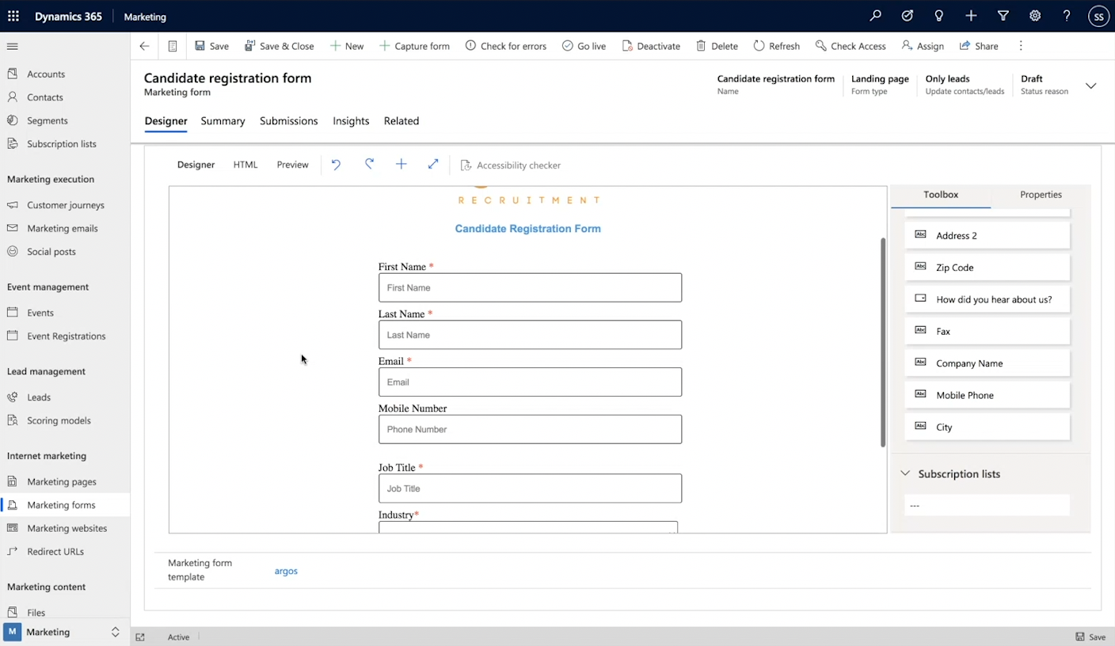

An example marketing thank you page/confirmation page, that could be used to display after submission if you wanted to build the page in the system.

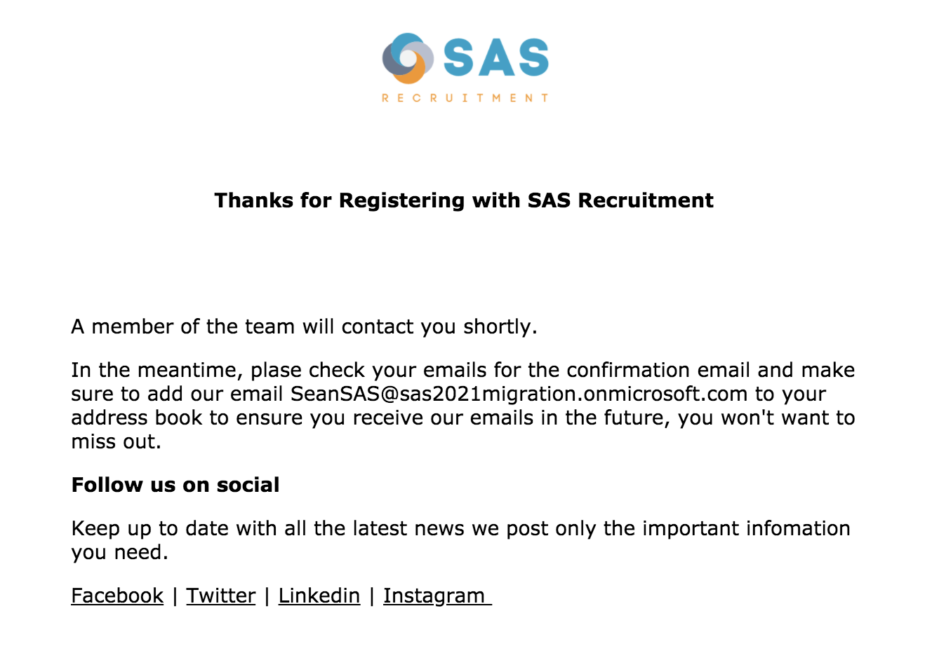

The screenshot below shows the options you can select like confirmation email, if you want the email to be double opt-in or not and open the marketing page or the thank you page as it is sometimes called.

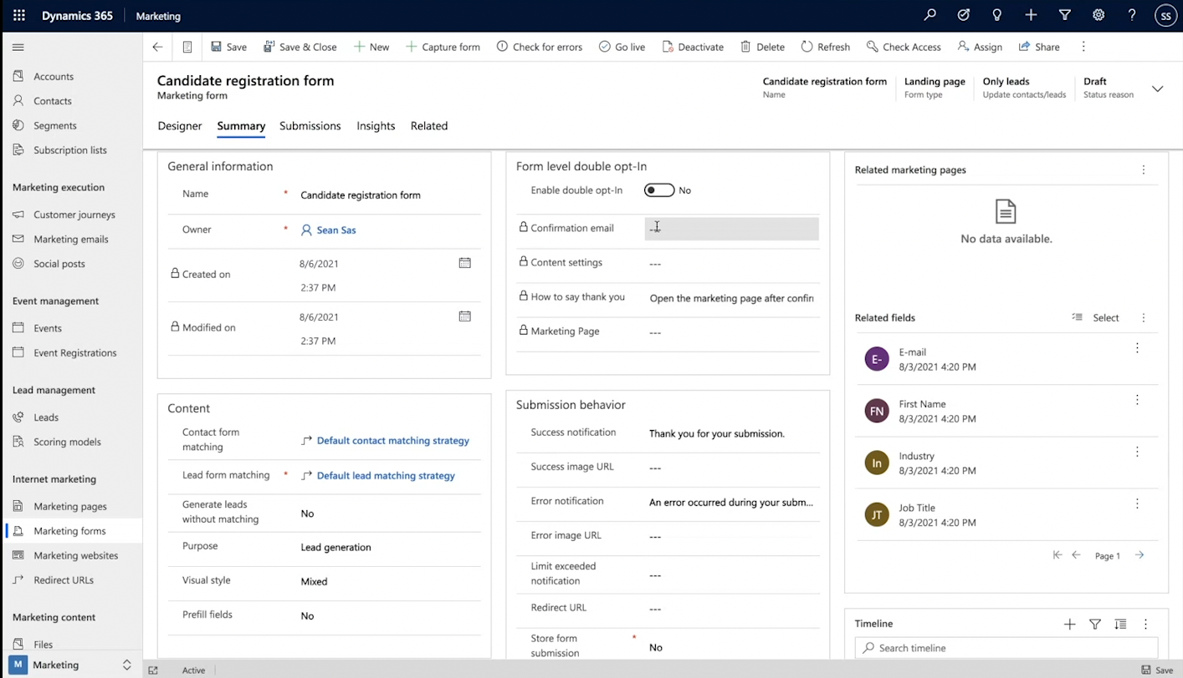

This screenshot shows the insights of the form, once submission start to roll in you will see the number go up in the specific sections such as submissions, leads, contacts, and if there were any errors recorded on submissions, this is good if needing to troubleshoot any issues in the future. Also if any current contacts have been updated you will see this here.

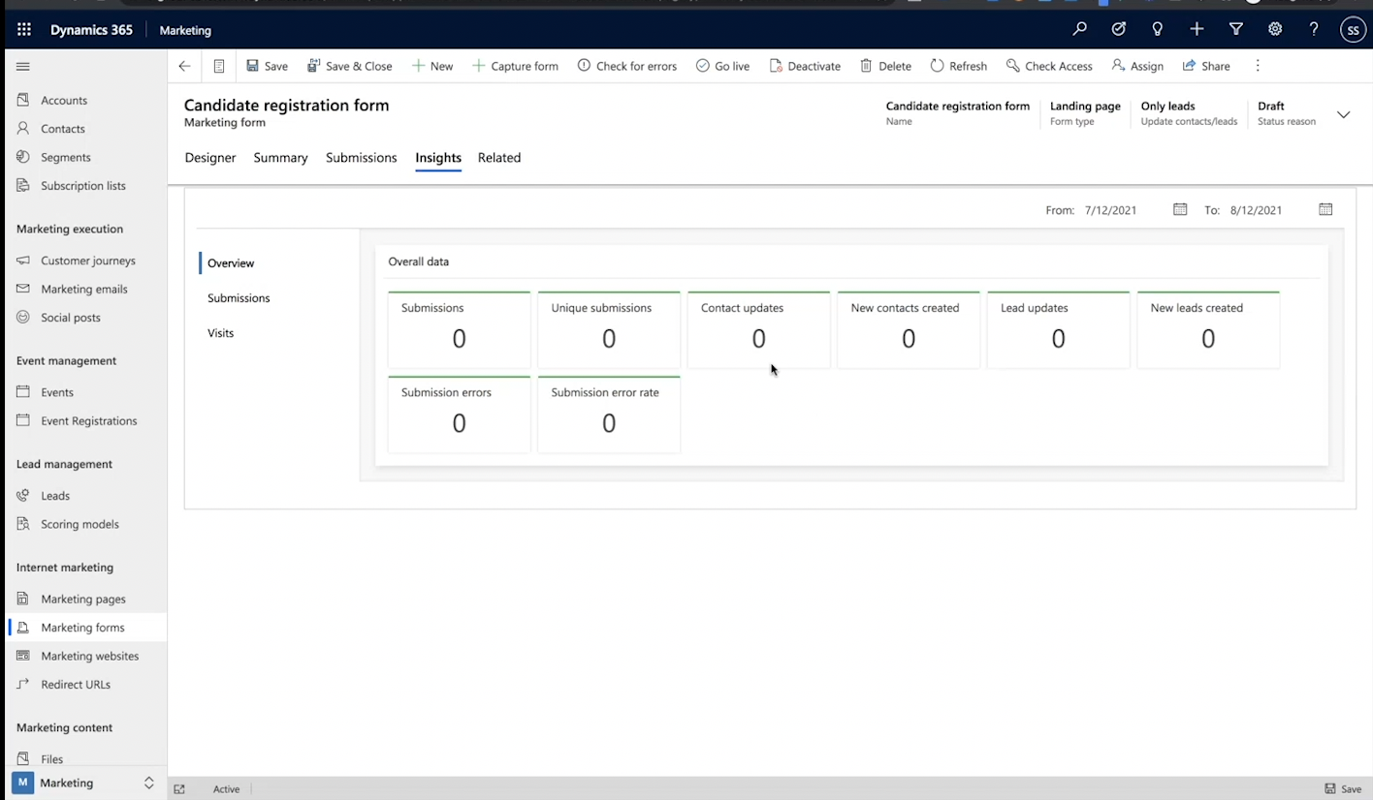

**Marketing lists in MS Dynamics Marketing:**

The marketing lists section is where we select the email addresses to send out of marketing emails from and set processes for following up via phone call. It is a list of potential clients that have reached out to use through a form on the website in the past, or have signed up through an email for updates from us. A marketing email could be along the lines of how well our last month went, how many candidates we placed and in what sectors, letting the readers see how well we are doing and a call to action asking them to reach out to us to become a client today. On the left-hand side under Marketing select Marketing Lists, you will see the entire list. For the project Mockaroo data was used and Microsoft Dynamics has a number of templates to download for manually uploading the data and using the marketing lists template and with excel filled the data.

Setting up a demo campaign by selecting Campaigns under Marketing also. This is where the email you want to send it created and if you want to follow up with another action like a telephone call. You can select the dates to run the campaign for also. Setting a campaign code and an expected response percentage if you wish. You can select the marketing lists you want the email to go to and any other leads you may want to add can be done here too.

Marketing is a key process in gaining and retaining clients and candidates and Microsoft Dynamics is very useful to allow these processes to keep track of all the marketing collateral.

The screenshot below shows the Marketing List.

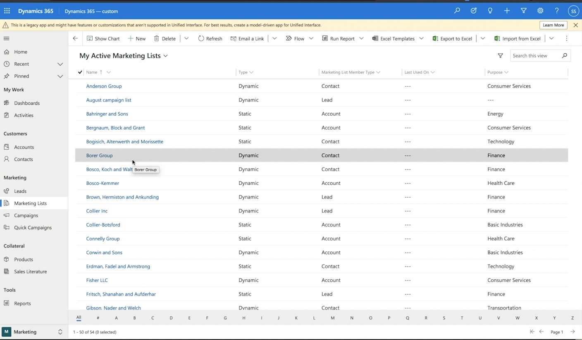

The screenshot shows the Demo campaign created.

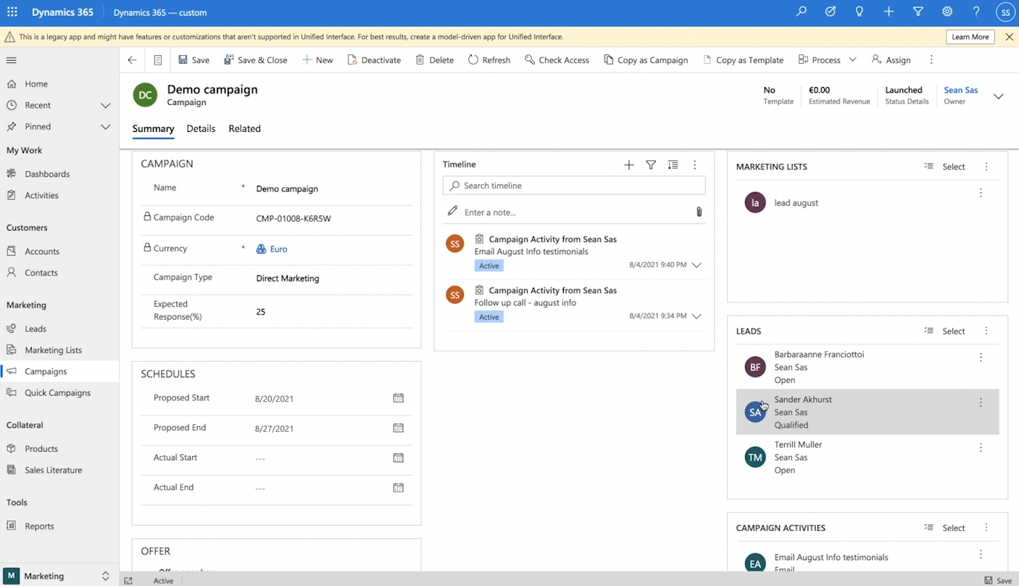

**Managing the Sales with Microsoft Dynamics:**

The Sales on Dynamics are managed in the sector Opportunities, in the left bottom. When moving the data from the various branches into the cloud, the files have been imported in bulk using the import function that allows to import big excel files. After that, a single recruiter can insert a single record, corresponding to a job vacancy, inserting all the data related to it. The following screenshot shows a list of job vacancies, the client, the status of the opportunity (in this case set to won and closed), the revenue and the date the deal was closed.

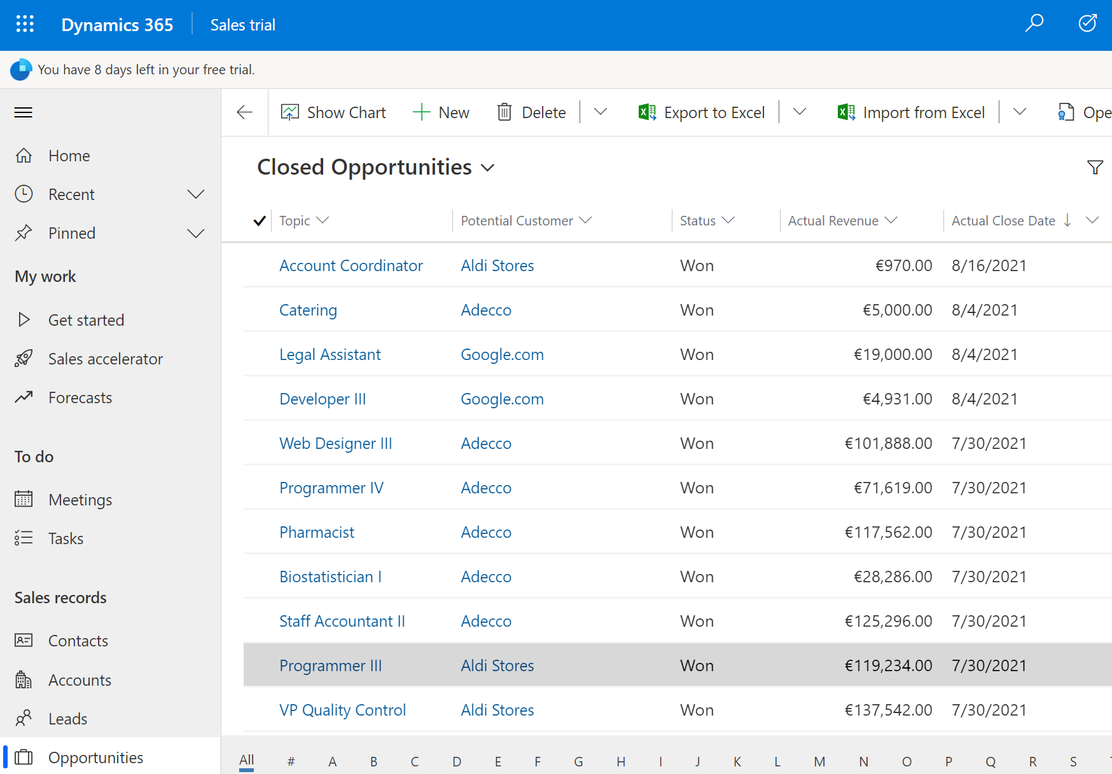

It is interesting to notice that the same view allows to visualize a very high amount of graphs that can be chosen from the list Chart:

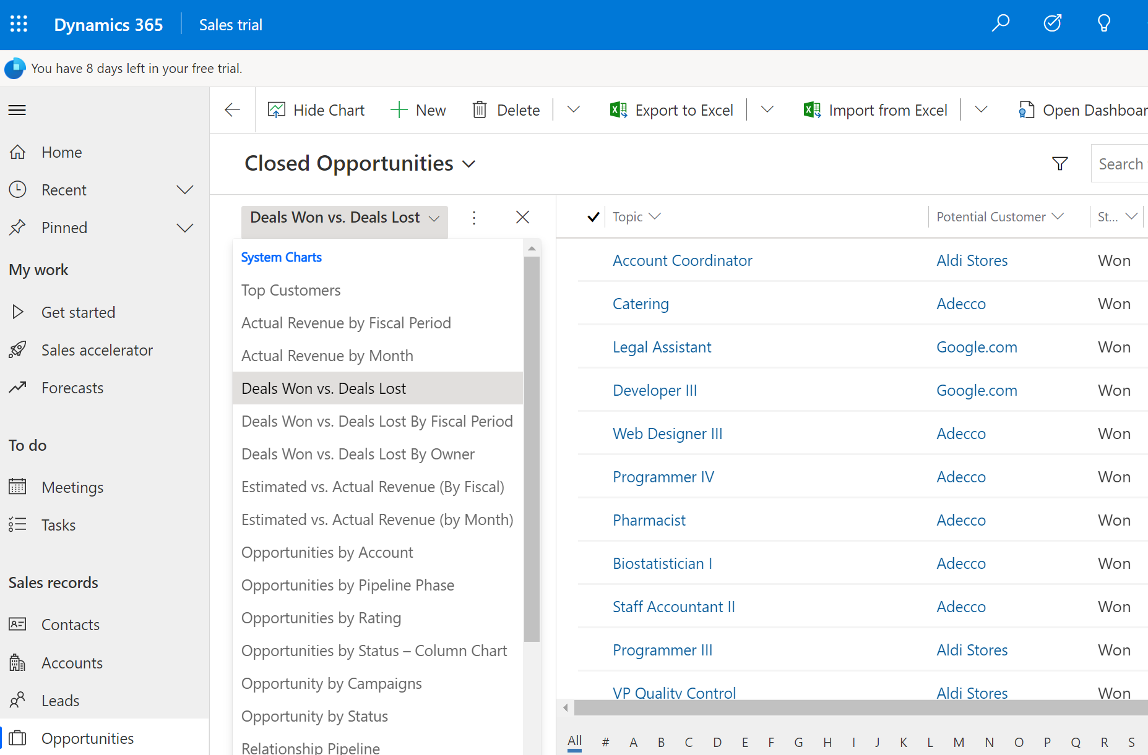

Giving an immediate graphical insight into the dashboards without the need to use external tools. The following picture shows an example of the revenue generated for closed opportunities by each client. Hoovering over the name of the account, the revenue generated shows up automatically:

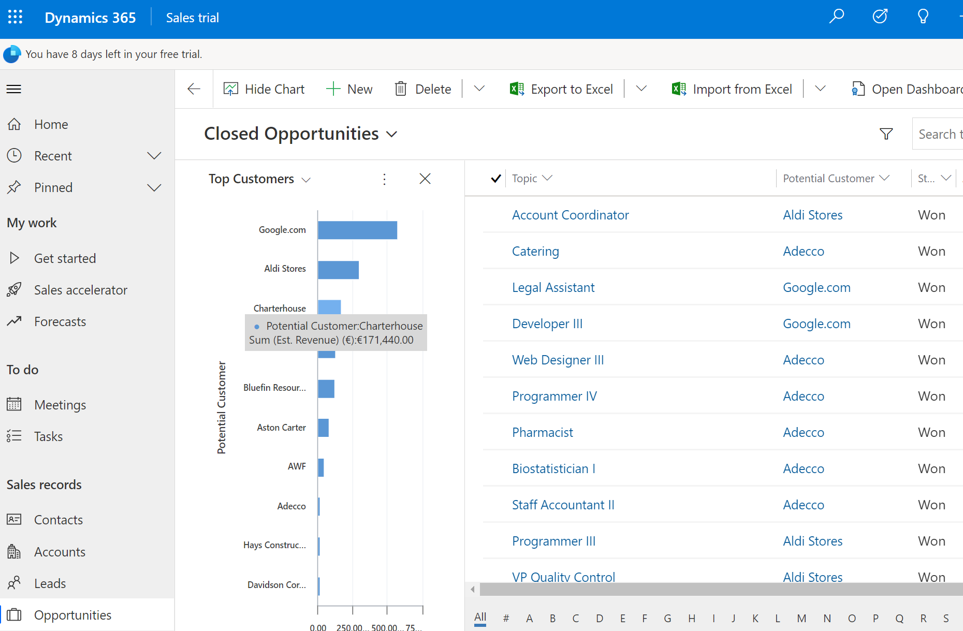

**Managing Candidates on MS Dynamics**

Each candidate has a separate workflow whereby it is possible to step each candidate throught the process:

Step 1: Quality = Candidate Screening

Step 2: Develop = Candidate Interview

Step 3: Propose = Candidate Offer/Rejection

Step 4: Close

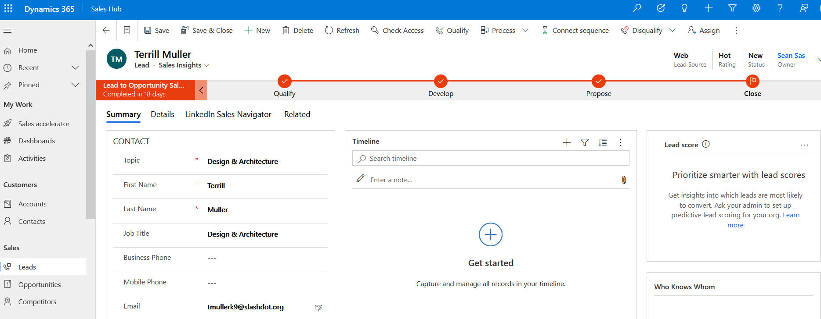

## 5.1.2 Dashboards

The dashboards allow a visualization of the data in SAS Recruitment, this is a very important step in this process. Being able to visualize the data about the company will in turn allow for better decision making based off past actions allowing the company to improve continuously by iterating for the next period ahead.

Tableau is a visualization software that is used for our dashboards. Power Bi is an alternative however based on personal decision we choose Tableau, also it works on Mac Operating System which is a bonus. We want to be inclusive for all systems if possible.

The main dashboards included are Strategic, Operational and Tactical.

## 5.1.3 Strategic Dashboard

A strategic dashboard is great for a view of long-term strategy within the company. It helps to keep the goals on track and aligned that you have set and or if you must pivot to keep aligned.

The dashboard has nice functionality that includes download as PDF, the branding of the company and some filters to interact with the data.

This dashboard shows the main success factors in SAS Recruitment those are number of candidates and number of jobs and the locations. This allows you to see at a glance the main factors needed to make strategic decisions. An example of seeing that more clients are needed in the Advertising category because there are many candidates looking for jobs in that area, however we only have a few jobs available. We would check to see if our goals align and if they do, we can note it for future areas for marketing spend to be allocated. If we notice a goal was set out to place X candidates in that area, we need to really find out why it is falling short and this dashboard helps us decide that.

Similarly, we can see how many locations job are in and the candidates we have in those areas also.

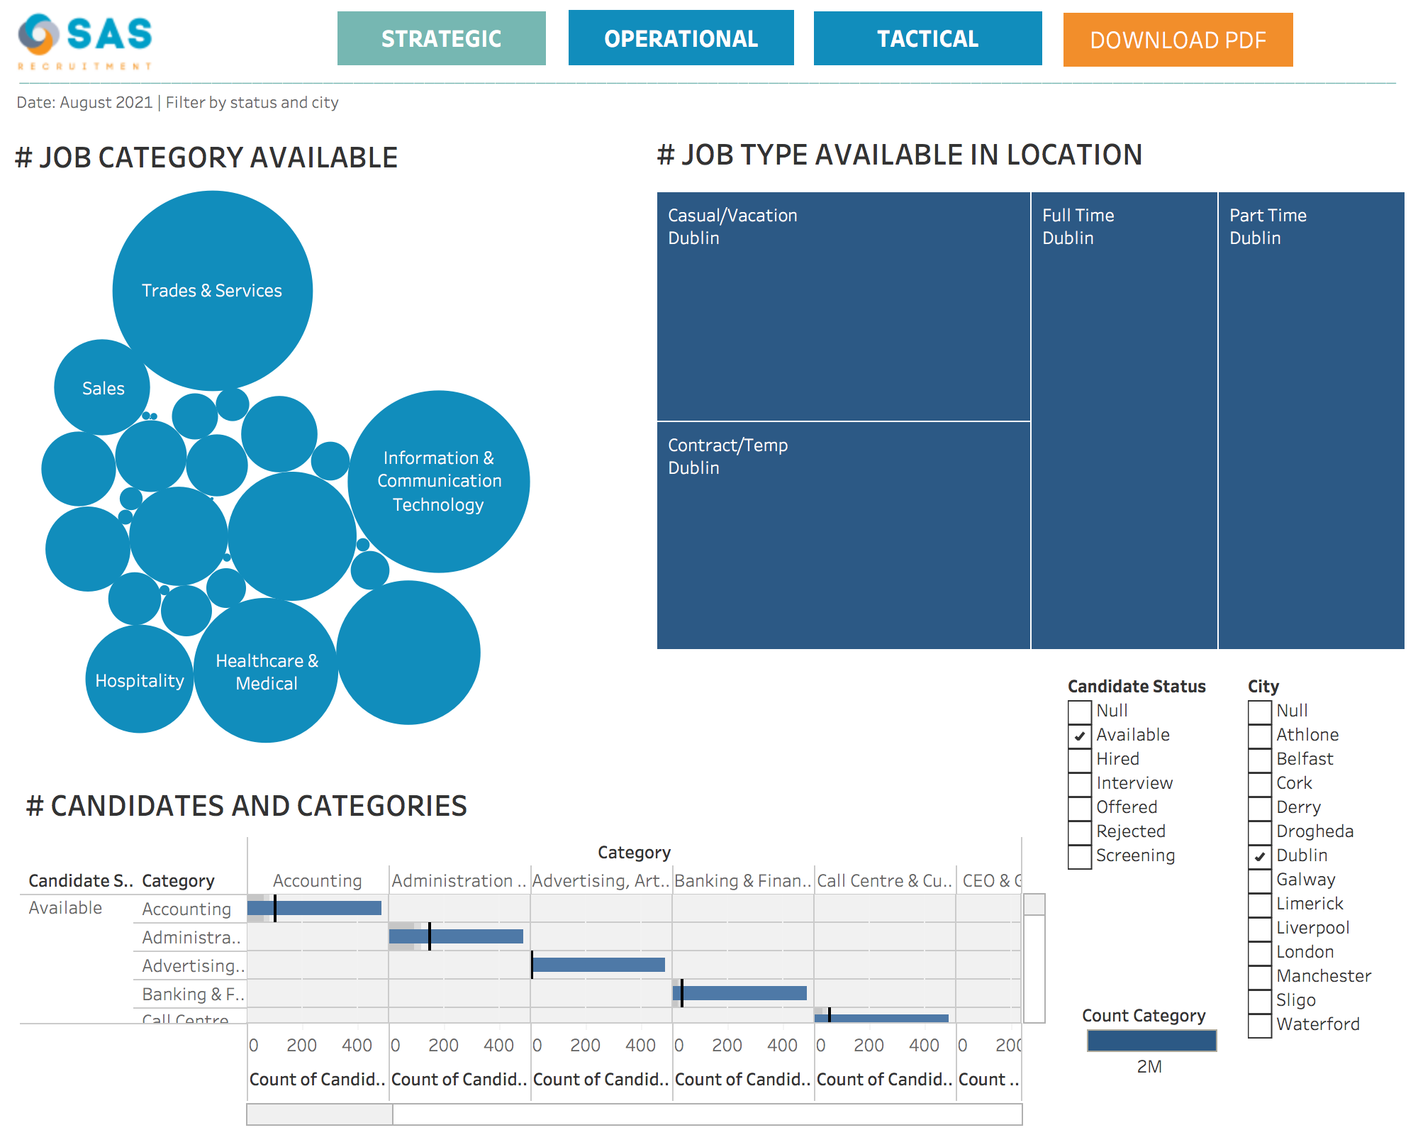

# 5.1.4 Operational Dashboards

Operational dashboards are designed to provide a quick overview of the short-term performances and are generally administrated by 'junior level of management'. Here are a few examples of operational dashboards created for the SAS Recruitment.

The first one contains the number of opportunities for September 2021, divide by week and by branch.

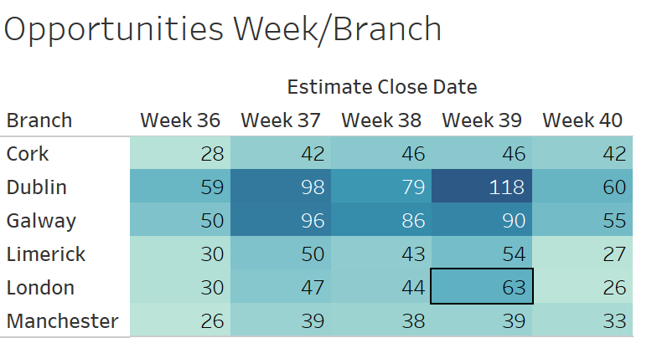

The following shows the number of opportunities per week divided by rating.

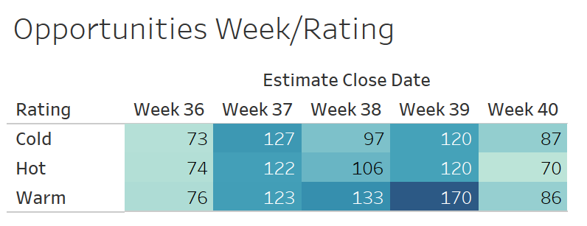

The following contains the number of opportunities divided by week, by branch and by employee. In this way, each employee knows the estimated closed date and can decide whether to spend his time closing the deals or checking for new opportunities. For example, in this mocked data, Anselma Ruegg, from the Dublin Branch, already has a very high number of opportunities with an estimate close week 39 and a good number in the weeks before. This information would suggest her to focus on closing deals rather than hunting for new ones.

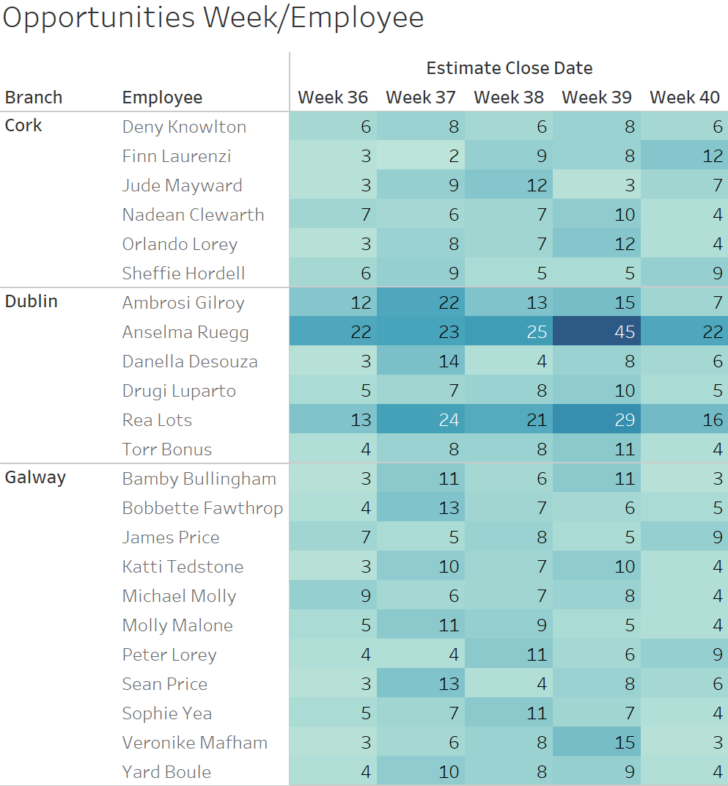

# 5.1.3 Tactical Dashboards

This tactical dashboard was created in order to quickly demonstrate to senior management which areas the company should focus on. The below bar chart confirms which categories are expected to generate the most income along with a heatmap outlining where each job vacancy is located and the Job Type, this allows Senior Management to provide updates to the regional offices which should maximise profitability and efficiency.

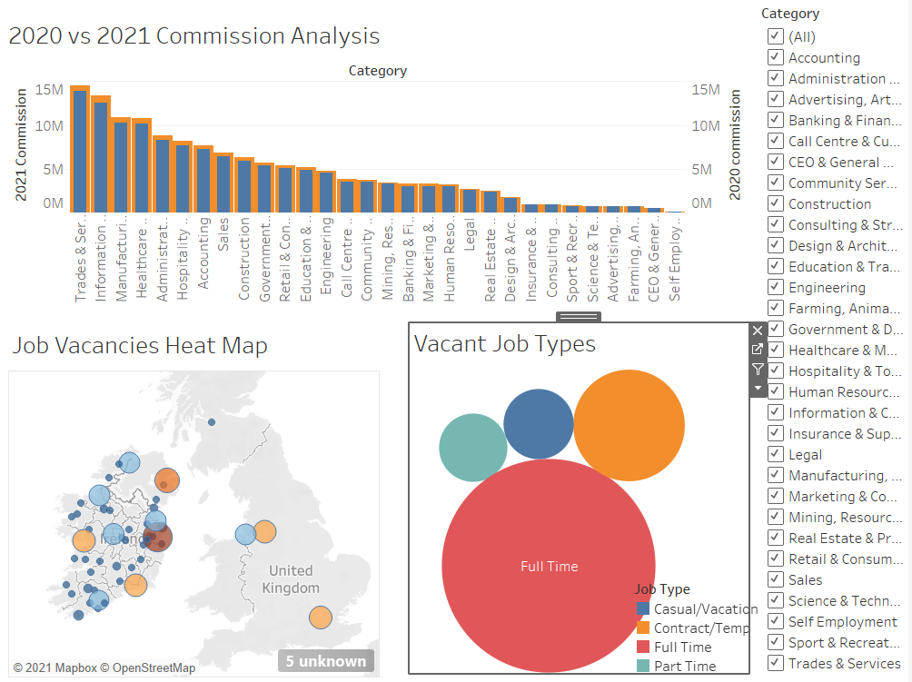

# Benefits

## Company Benefits

Continuous Improvement Programs (CIP) have many benefits including improving the quality, employee satisfaction and teamwork, customer happiness, reducing waste with standard processes and costs by identifying issues before they occur. The tracking of data and processes will allow changes to be made for the better going forward. Below are some of these in more detail.

Using Microsoft Dynamics 365 sales and marketing has many benefits for SAS Recruitment. It takes care of the customer needs, connecting and supporting the organisation with sales, marketing, customer service and building a framework from customer support. This is what connects the brand SAS Recruitment with the employees and prospecting customers and manages the current customer lifecycle.

The ability to have predefined workflows that enable tracking of customer interactions, documents and other information we need to store. The ability to follow up with leads (marketing lists) to close the sale or in our case win a contract to supply employees to the client.

A reduction in paperwork that is better for the company as whole. Saving money on paper and printing. Saving on office space with reduced filing cabinets. The employees also waste less time searching through paper documents, less chance of human error with data entry. It also has great benefits on the environment, a step in the right direction for reducing the companies carbon footprint.

All data stored in one central database, that can be accessed by the right people at any time. This allows viewing of the main office and the other locations for all high-level staff members to make better informed decisions going forward, with the important information available and easily accessible. For the smaller companies their management staff can also see their stats and make decisions on those. Better transparency for the whole company. Viewing where the profits are made and where the spend is going will also help for the marketing team and guide decisions on budgets for the next quarter based on the last.

Allowing different users to see the right information will ensure safe storing of personal data for example payroll details only viewed by accounting.

Using a CRM will benefit the company by ensuring better relationships with candidates and clients by creating better relationships, knowing the history of interactions.

Having more knowledge at the recruiter’s fingertips will also make sure to find suitable roles for the candidates quicker with better search functionality. In the past the paper documents would be hit and miss if matching candidates to roles, human error often led missing opportunities. Therefore, increasing the placed candidates will mean more commission for the recruiter, this will help with the change adoption and training, more revenue for the business and more happily placed candidates that would recommend the business to friends.

The inbuilt form capability in the marketing version will remove the need for a third-party software. Multiple forms are created for Candidate registration, Client Registration, Contact Us and these can be edited within the software. The HTML code can then be paced onto the web developer to add to the specific pages on the website. The information is mapped directly into the system to save the details.

The ability to show dashboards for various areas of the business will help with decision making and future planning. Having the historic data to compare will be a great visual to show high level management. Profits, spending, budgets, goals, planning…

Dashboards for internal operations will be useful for holiday planning also, at a glance see who is off at specific times of the year to ensure there is no under staffing.

Removal of third-party software that was previously used will save costs and streamline the amount of data being passed that could lead to a data breach, this is a safer option to have all data in one place.

The BSC is also a benefit that provides the company with a framework to align to. This is a strategy that links all the projects/processes to measures and each measure to set strategy to be transparent to all involved and accountable. It allows the business to be responsive change going forward and plan the next steps.

## Employee Benefits

At first the employees may not like the sound of a new system to use every day. They have become accustom to the old system even though it is slow and out of date they know the exactly how to use it and are capable at getting the job in question done as fast as they think it is possible. This is normal for many businesses, many employees fear change as mentioned in our methodology, this has been taken into account.

Microsoft Dynamics will speed up many processes. For example, details will come from the website forms directly into the system as leads for candidates, accounts for clients and marketing lists for any potential clients that showed an interest and signed up on the website. A huge benefit for the employee, saving time and possibility of human error. The removal of human error due to not needing to copy data from many sources also means better quality data.

More time focused on placing candidates with jobs and dealing with them to make sure they are the right fit; the more candidates placed the more commission earned by the employee.

Having all the client and candidates details in the one system and being able to search the entire list all on the system will ensure fasting matching again and more detailed searches.

With the ease of entering the information into the website forms from a user’s point of view, there is less friction in the registration process therefore more candidates will be able to sign up. This is also down to a good user experience on the website, clearly outlining the call to action is to fill out the form and how to do so and what will happen next in the process.

At a glance being able to see the number of live candidates will be great for setting goals.

Once more and more candidates go through the short process and get placed, they will start to spread the word of success to their friends and family, word of mouth is great for company reputation, which could in turn lead to more people apply and registering for jobs with SAS Recruitment.

Sending emails directly from the system will also save a third-party tool being used. This retaining of current clients by sending valuable information on last month’s wins and how many candidates we placed, will provide the connection and center SAS Recruitment as a growing company doing great work.

Another perk for employees would be internal process of holiday views – being able to see the remaining holidays on a dashboard view.

Upskilling with new software that is well known in other businesses is great for the employee and they can use this new skill in the future.

# Future Work

During our initial analysis while selecting a suitable CRM, we tried to look at the whole package rather than just the tools that we required. In doing so, our decision to select the Microsoft Dynamic Sales Hub and Marketing Hub was based on the overall Microsoft Dynamics package.

Some of the other Dynamics tools which we believe would benefit the company are the following:

* MS Dynamics Human Resources
* MS Dynamics Customer Services
* MS Dynamics Finance

Along with these services, MS Dynamics also additional features such as MS Dynamics for MS Outlook, Chatbot builders and AI features which would benefit the company.

Upon successfully implementation of this project, we would like to undergo detailed cost benefit analysis for each item.

# Teamwork

Our team worked collaboratively on this project, we divided out the sections to work on and then reviewed all work weekly and made changes as per the meeting and iterated over the scope until got a final product. Sean set up a GitHub project to keep track of our tasks and who would be in charge of each task. We all took some time to review each other’s sections to make sure we had no mistakes, before sending to the company. We met frequently on Microsoft Teams and shared our files through the files tab.

We initially created 4 separate work areas as follows:

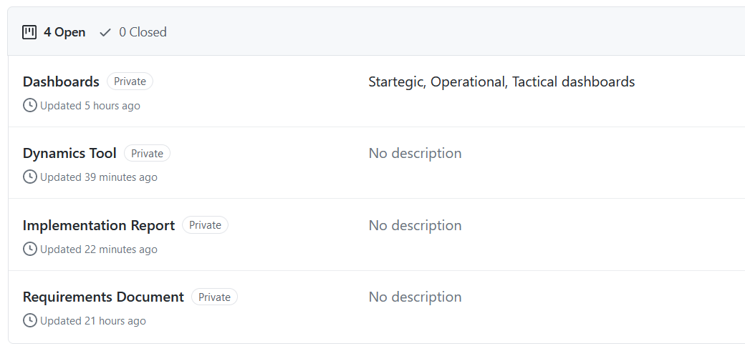

Within each of these work areas, we added tasks during our weekly catch up and assigned them to each other.

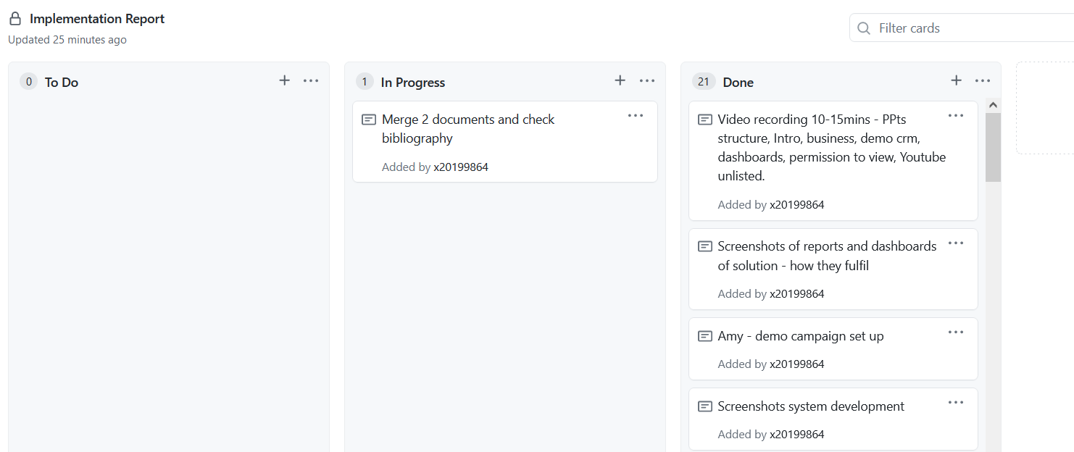

All tasks were initially added within the ‘To-Do’ column, then later assigned to a colleague. Once each person picked up their task and began working on it, they moved it into the ‘In Progress’ column. Upon completion, the task was moved into the ‘Done/Complete’ work area.

We found this system very efficient and easy to manage, tasks were evenly assigned to each group member and we were able to track how each member was progressing. At our weekly checkpoint we had the opportunity to discuss our previous updates.

Microsoft Teams files section was used to keep track of our files. We could update documents at the same time which was very useful for the likes of the report writing being a collaborative effort. Here is a screenshot of how our files looked. It also kept new versions of files for and we could all see at a glance what had been updated last and by who.

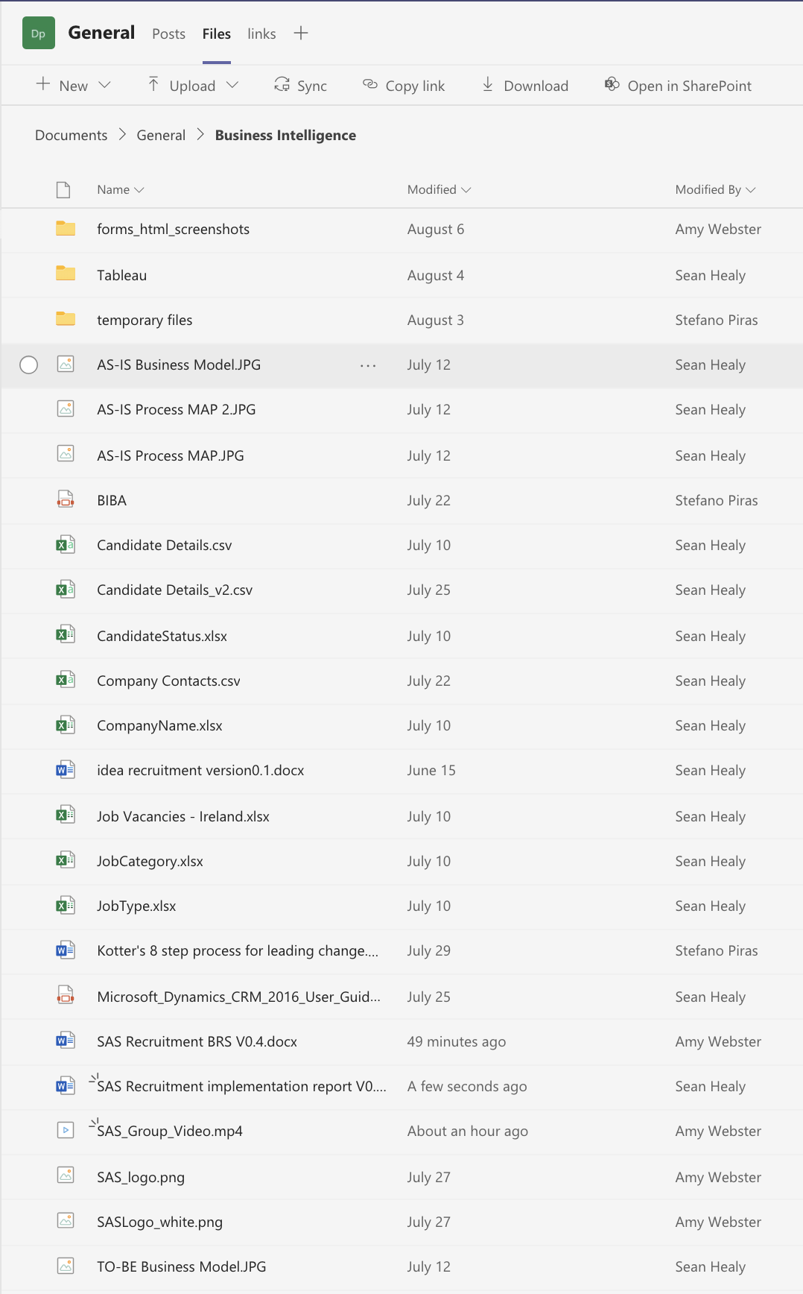

# Glossary

|  |  |
| --- | --- |
| Term | Description |
| BSC | Balanced Score Card |
| DAM | Database Activity Monitoring |
| GDPR | General Data Protection Regulation |
| BA | Business Analyst |
| ERP | Enterprise Resource Planning |
| CRM | Customer Relationship Management |
| COO | Chief Operations Officer |
| B2B | Business to Business |
| B2C | Business to Customer |
| SaaS | Software as a service |
| CIP | Continuous Improvement Programs |

# Bibliography

|  |  |
| --- | --- |
| [1] | "Investopedia," [Online]. Available: <https://www.investopedia.com/terms/s/swot.asp>. [Accessed 26 July 2021]. |
| [1] | J. Kotter, "<https://www.kotterinc.com/>," [Online]. Available: <https://www.kotterinc.com/>. [Accessed 27 July 2021]. |
| [2] | J. Kotter, "<https://www.kotterinc.com/>," [Online]. Available: <https://www.kotterinc.com/8-steps-process-for-leading-change/>. [Accessed 27 July 2021]. |
| [3] | J. P. Kotter, Heart of Change: Real-Life Stories of How People Change Their Organizations, Harvard Business Review Press; 1st edition (November 1, 2012), November 1, 2012. |
| [4] | R. Tanner, "Management is a journey," [Online]. Available: <https://managementisajourney.com/leading-change-step-2-create-the-guiding-coalition/>. [Accessed 27 July 2021]. |
| [5] | T. v. Ahn, "LinkedIn," 6 April 2015. [Online]. Available: <https://www.linkedin.com/pulse/change-management-process-step-4-enlisting-volunteer-army-von-ahn/>. [Accessed 27 July 2021]. |
| [6] | J. P. Kotter, Leading Change, Harvard Business Review Press;, 2012. |



# Appendix

* + 1. Mockup of website home page. This was created for the website developer to improve the existing site. This mockup is created using prototyping software called Figma. The main call to actions are more prominent on the site; jobs and contact, candidate, clients.

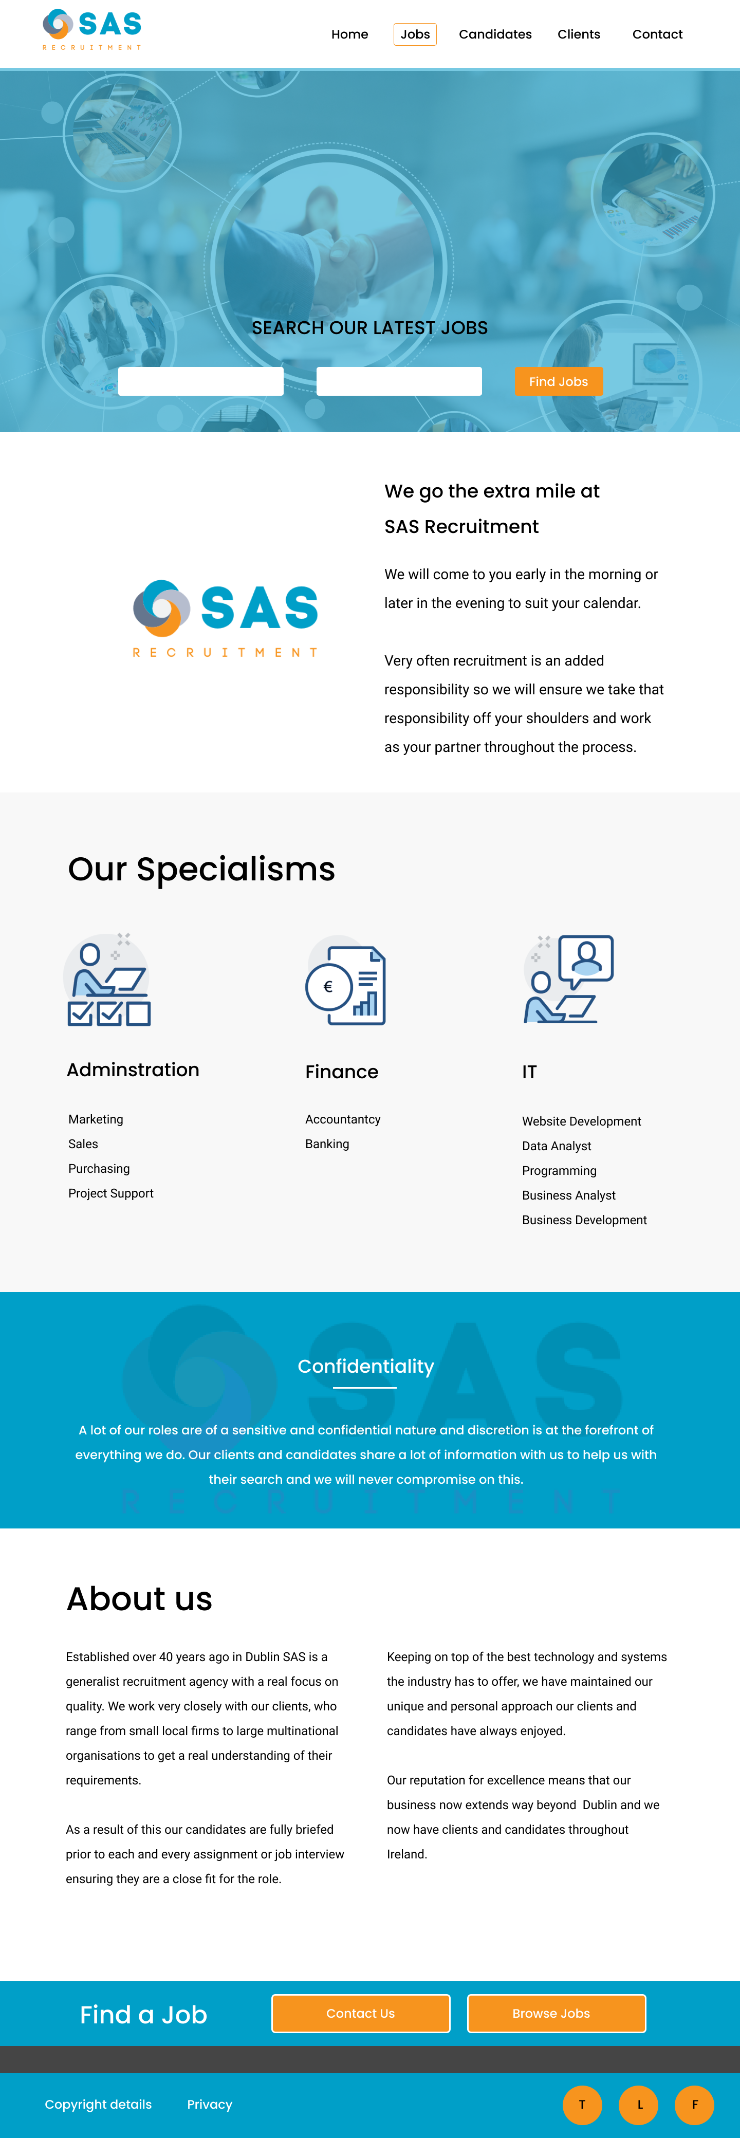

9.1.2 Forms created in Microsoft Dynamics Marketing. The forms are created within the software and produce HTML code to pass on to the website developer. The pages will be created on the website and these HTML forms will be added. HTML attached in zip file.

a. candidate registration form

b. client registration/ staff request form

c. contact us

1. 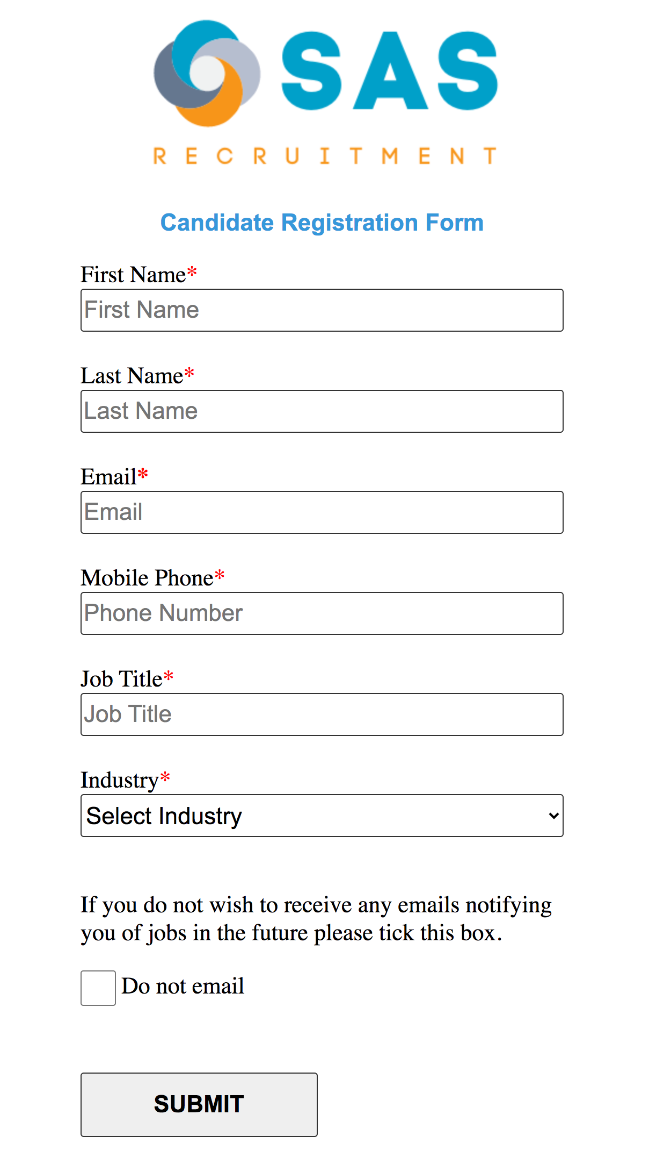
2. 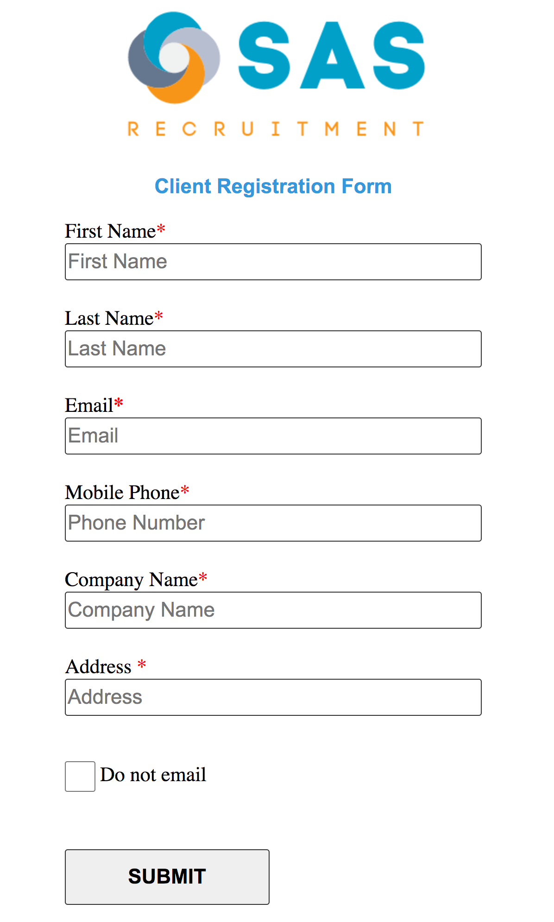
3. 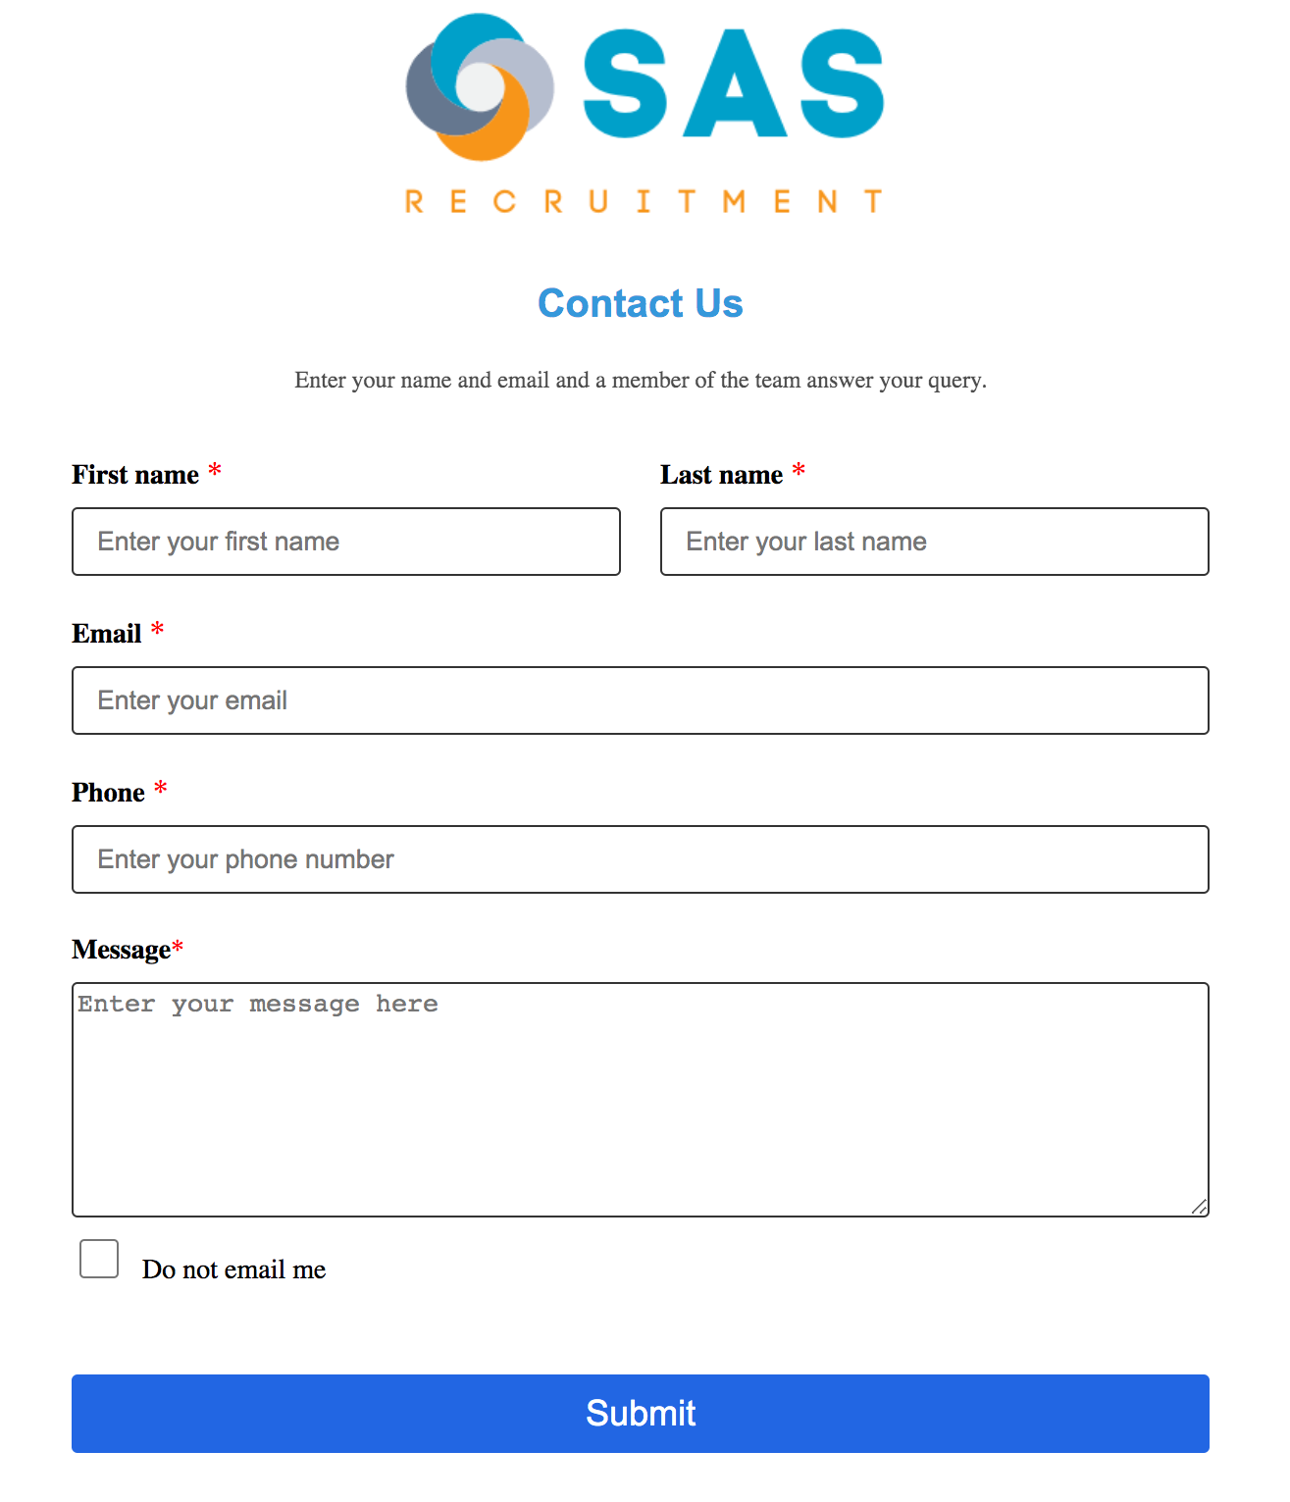

The HTML of the form created has been added in .HTML files separately, these will open in a browser and can be viewed.